Introduction to Georgia FCCLA Competitive Events

This year Georgia FCCLA will have 10 state competitive events. These events will showcase individual proficiency and achievement in the knowledge of the Family and Consumer Sciences, Culinary, and Education. These events will offer individual skill development and application of learning through individualization and competition. These events are not available at the region level and competitors will not be advancing to national competition.

The Georgia FCCLA Competitive Events will recognize accomplishments in individual youth. The belief that everyone can be successful is the foundation of these events. Cooperation and competition are stressed in positive, constructive ways.

State Events

Baking & Pastry (High School Level) - an individual event, recognizes participants who demonstrate their creativity in creating an original cake design. Participants must be currently or previously enrolled in a Culinary Arts Class.

Baking & Pastry (Middle School Level) - an individual event, recognizes participants who demonstrate their creativity in decorating an original cupcake design. Participants must be currently or previously enrolled in a Family and Consumer Sciences Class.

General Requirements

All Georgia FCCLA Competitive Event participants must be state and nationally affiliated members of an FCCLA chapter. Participants must register for and attend the entire State Leadership Conference to officially enter the competitive events. An individual member may participate in only one event in any given year. Individual events evaluate one member’s performance. These events are not open to State STAR Events Competitors.

Registration

To register for the Baking & Pastry Event, you must first register the student for State Leadership
Meeting and click on “Event” next to their name once they are added. You will then click “Baking & Pastry Event”. Competition fee is $5.00. Once registration has closed on March 6 you will receive additional information regarding the Event.

State Recognition

All participants will receive a certificate of participation. The following will be given to the top 3 individuals:
1st Place- $200
2nd Place- $100
3rd Place- $50
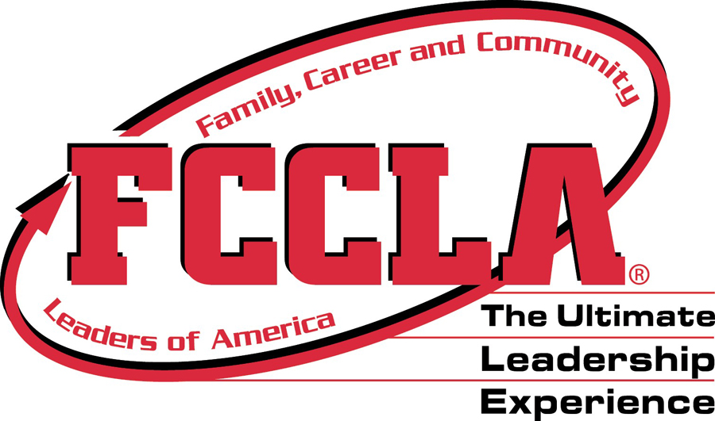

Baking & Pastry (High School Level)

Eligibility
1. Chapters may submit one entry into this event.

2. Participation is open to any nationally affiliated FCCLA chapter member currently taking or previously in a Culinary Arts class.

3. Participants must be registered for the State Leadership Conference and may not participate in any other state STAR event.

Procedures and Time Requirements
1. Students will sign in and receive a participant number- which must be worn on their chef coat. The Baking & Pastry Event will take place in Grand Hall. Sign-in will begin at 8:30am and the competition will start at 9:00am. Competition is limited to the first 20 signed up on the State Meeting Registration site. If a school drops out, then an alternate will be selected. The competition is open to spectators.

2. Judges will disqualify previously published recipes, such as but not limited to those in major cookbooks, magazines, or from food companies. All baking items must be original and not premade.

3. All participants must bring:
- 2 copies of their recipe on 8 x11, white paper, free of decorations.
REQUIRED: In the top left corner label: Name, School, Grade and Theme.
- All ingredients they will need for batter, icing, and decoration. Fondant may be allowed for decorating but must not be used for covering the entire cake.
- Premade cake (any sizes)
- All equipment needed to prepare the recipe (measuring spoons, cups, bowls, rubber spatulas, etc), sanitation buckets, sanitizing solution, 1 gallon of water, and hand towels. All mise en place must be done onsite.
**NO STAND MIXERS (no electricity is available & space will be limited, YOU MAY BRING A HAND MIXER to mix ingredients and one butane burner)

4. Participants will be given 90 minutes to prepare their decorated cake. Cakes must be decorated and you chose the theme. We encourage the use of edible decorations. Participants will assemble one cake for judging.

5. Plates will be judged on taste, creativity, ease of preparation and consumer appeal by a panel of food experts/chefs.

General Information
Participants will be well groomed and wear appropriate, clean attire, meeting restaurant and hotel industry standards including: chef coat or jacket; industry pants; apron; hair covering or chef hat; closed toe, low heel shoes. PLEASE COVER UP SCHOOL NAMES ON CHEF COATS WITH MASKING TAPE PRIOR TO COMPETITION.

High School Baking & Pastry
JUDGES RATING SHEET

COMPETITOR NAME: __________________________________________ Participant #: ___________

COMPETITOR SCHOOL: ________________________________________ Judges Initials: _________

Evaluation Criteria | Points Possible  Needs Good Exemplary  Improvement  0-4 5-7 8-10 | Points Awarded
Safety & Appearance
Clothing & Appearance | Non-professional Neat appearance Professional  appearance, attire attire & grooming appearance,  and/or grooming but lacks polish attire & grooming
Safety | Disregard of safety Shows minimal Follows all  creating unsafe safety concerns safety practices  situation during  presentation
Sanitation | Unsanitary situation Shows minimal Follows all  creates unsafe product sanitation concerns sanitation practices  during presentation
Preparation Temperature | Food items not Some food items All food items were  held/handled to not held/handled to held/handled at  maintain proper temps. maintain proper temps. proper temps.
Equipment & Tools
Equipment, Tools &  Techniques | Selection & usage of Selection & usage of Selects and uses all  tools/equipment lacks tools/equipment tools/equipment  understanding and occasionally lacks safe correctly & safely  demonstration of skills understanding & appropriate  industry techniques
Food Production
Time Management | Pool utilization of Good utilization of time Exemplary use of  time, plates were late time
Recipe Direction | Did not follow recipe Partially followed recipe Followed recipe  or proper sequence and proper sequence & proper sequence
Food Presentation
Product Appearance | Presentation needs Presentation is acceptable, Presentation is  Improvement but lacks professional attractive and shows  qualities creativity
Product Taste | Questionable taste Adequate, but not Pleasing, appropriate  outstanding taste
Theme | Little or no theme Adequate, but not Exemplary use of  used outstanding theme
Creativity | Lacks creativity Adequate but not Exceptional creative  outstanding ideas
TOTAL POINTS

Please include additional comments on the back of this rating sheet, if desired.

Baking & Pastry (Middle School Level)

Eligibility
1. Chapters may submit one entry into this event.

2. Participation is open to any nationally affiliated FCCLA chapter member currently taking or previously in a Middle School Family and Consumer Sciences class.

3. Participants must be registered for the State Leadership Conference and may not participate in any other state STAR event.

Procedures and Time Requirements
1. Students will sign in and receive a participant number- which must be worn on their apron. The Baking & Pastry Event will take place in Grand Hall. Sign-in will begin at 1pm and the competition will start at 1:30pm. Competition is limited to the first 20 signed up on the State Meeting Registration site. If a school drops out, then an alternate will be selected. The competition is open to spectators.

2. Students may bring 6 premade cupcakes and then decorate them onsite. Two needed for judging.

3. All participants must bring:
- 2 copies of their recipe on 8 x11, white paper, free of decorations.
REQUIRED: In the top left corner label: Name, School, Grade and Theme.
- All ingredients they will need for icing and decoration
- All equipment needed to prepare the recipe (measuring spoons, cups, bowls, rubber spatulas, etc), sanitation buckets, sanitizing solution, 1 gallon of water, and hand towels. All mise en place must be done onsite.
**NO STAND MIXERS (no electricity is available & space will be limited, YOU MAY BRING A HAND MIXER to mix ingredients )

4. Participants will be given 30 minutes to prepare their decorated cupcake. Cupcakes must be decorated onsite and you chose the theme. We encourage the use of edible decorations. Participants will assemble one cupcake for judging and one cupcake for display.

5. Plates will be judged on taste, creativity, ease of preparation and consumer appeal by a panel of food experts/chefs.

General Information
Participants will be well groomed and wear appropriate, clean attire, meeting sanitation standards including: apron; hair covering or chef hat; closed toe, low heel shoes.

Middle School Baking & Pastry
JUDGES RATING SHEET

COMPETITOR NAME: __________________________________________ Participant #: ___________

COMPETITOR SCHOOL: ________________________________________ Judges Initials: _________

Evaluation Criteria | Points Possible  Needs Good Exemplary  Improvement  0-4 5-7 8-10 | Points Awarded
Safety & Appearance
Clothing & Appearance | Non-professional Neat appearance Professional  appearance, attire attire & grooming appearance,  and/or grooming but lacks polish attire & grooming
Safety | Disregard of safety Shows minimal Follows all  creating unsafe safety concerns safety practices  situation during  presentation
Sanitation | Unsanitary situation Shows minimal Follows all  creates unsafe product sanitation concerns sanitation practices  during presentation
Equipment & Tools
Equipment, Tools &  Techniques | Selection & usage of Selection & usage of Selects and uses all  tools/equipment lacks tools/equipment tools/equipment  understanding and occasionally lacks safe correctly & safely  demonstration of skills understanding & appropriate  industry techniques
Food Production
Time Management | Pool utilization of Good utilization of time Exemplary use of  time, plates were late time
Recipe Direction | Did not follow recipe Partially followed recipe Followed recipe  or proper sequence and proper sequence & proper sequence
Food Presentation
Product Appearance | Presentation needs Presentation is acceptable, Presentation is  Improvement but lacks professional attractive and shows  qualities creativity
Product Taste | Questionable taste Adequate, but not Pleasing, appropriate  outstanding taste
Theme | Little or no theme Adequate, but not Exemplary use of  used outstanding theme
Creativity | Lacks creativity Adequate but not Exceptional creative  outstanding ideas
TOTAL POINTS

Please include additional comments on the back of this rating sheet, if desired.

