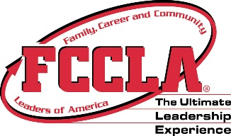 FCCLA Informational Sheet
Name _____________________________________________ Period _________
- FCCLA stands for
________________________ ,
_______________________
and ___________________
_______________________
of _____________________.

- What is the State and National Theme this year? _____________________________

- FCCLA central focus is the _________________________ and ______________ ____________.

- Name one benefit of joining a student organization.

- How many members in the state of Georgia? __________________ How many chapters? _____

- Colors: _______________ and _____________________ which are a symbol of ________________ and _____________________.

- Flower: _____________ ________________ and it represents __________________.

- Motto: _________________ _____________ ______________________ and what does it mean?

- When was FHA/FCCLA Founded? _________________

- FHA stands for ________________________ _____________________________ of ___________________.

- Who was the first state director for FHA? ________________ _________________________

- What did NHA stand for? ________________ __________________ of ____________________

- Who was the state director for NHA? __________________ _______________________

- What date the name change?

- What are the state and national competitions called? ________________ ____________________

- What does STAR Events stand for? _____________ _________________ ________________ for ________________________.

- Name 3 of the STAR Event competitions ________________________________________

- Where is the National Headquarters located? ________________ , ___________________

- List 3 National Programs and explain one of the projects you could do:

- Name one of the FCCLA Fall Conferences or Events happening this year?

- Where the State Leadership Meeting held this year?

- Where is the National Leadership Conference?

