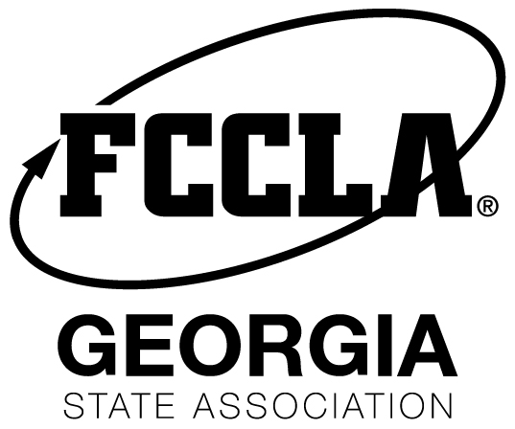

Title/Headline

Contact: (Chapter Adviser Info)
Phone: chapter advisor phone and email address
FOR IMMEDIATE RELEASE
Month Day, Year

City, State Initial According to APStyle Guide

Tips
Press Release Tips
- Make sure the release answers the questions WHO, WHAT, WHEN, WHERE, WHY
- Make sure title is concise but eye catching
- Keep it short! All paragraphs should be 1-4 sentences
- 1st paragraph should tell the point of the story. For example. On Sept. 15 FCCLA students went to Washington.
- Try your best to keep press release to one page
- See more tips here: https://www.theguardian.com/small-business-network/2014/jul/14/how-to-write-press-release
- Attach photos to email or include downloadable link

Basic description of Chapter business. Include where the chapter went, why they went, activities students participated in, and skills students learned. Include pictures with the article.

Quotation from Chapter Adviser.

Optional: Quotation from Chapter Members.

For more information on Georgia FCCLA, visit www.gafccla.com.

About FCCLA
Family, Career and Community Leaders of America (FCCLA), is a dynamic and effective national student organization that helps young men and women become leaders and address important personal, family, work, and societal issues through Family and Consumer Sciences education. FCCLA has over 150,000 members and over 6,500 chapters from 50 state associations, Puerto Rico, and the Virgin Islands. The organization has involved more than ten million youth since its founding in 1945.

FCCLA: The Ultimate Leadership Experience is unique among youth organizations because it is the only career and technical in-school student organization with the family as its central focus. Participation in national programs and chapter activities helps members become strong leaders in their families, careers, and communities.

###

