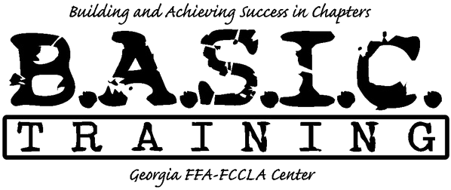
Chapter/Team Name

We can work with your schedule!

Day One:

5:00pm Arrive (move into cabins)
5:30pm Dinner
7:00pm General Recreation (Ping Pong, Basketball, etc)
9:00pm Campfire
10:30pm Return to Cabins

Day Two:

8:00 am Breakfast
9:00 am-11:30 am Team Building
11:30 am-11:45 am Option to Change in Cabins before Mud Course
12:00pm Lunch
1:00 pm Mud Obstacle Course
2:00 pm Back to Cabin to Change
3:00 pm Depart

