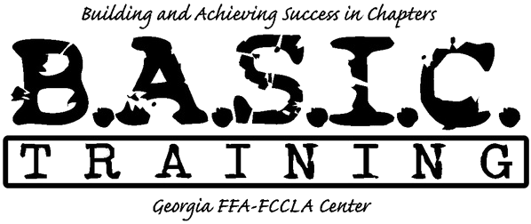
Chapter/Team Name

Day One:

8:30 am Arrive
9:00 am-11:30 am Team Building
11:30 am-11:45 am Option to Change in Cabins before Mud Course
12:00pm Lunch
1:00 pm Mud Obstacle Course
2:00 pm Back to Cabin to Change
3:00 pm Depart

