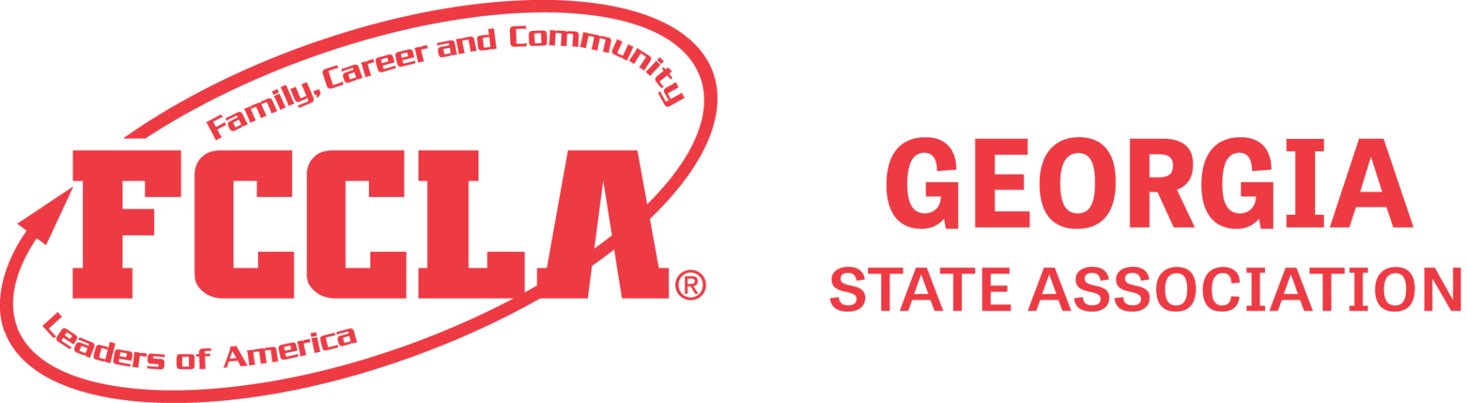

FOR IMMEDIATE RELEASE

Contact:
[Your Name]
[Your Position]
[Your Contact Information]
[Organization Website]

Georgia FCCLA State Leadership Conference Soars to New Heights with "Sky's the Limit" Theme

Athens, Georgia - March 19, 2024—Georgia FCCLA (Family, Career and Community Leaders of America) recently concluded its highly successful State Leadership Conference, held from March 17th to 19th at the Classic Center in Athens, Georgia. With the theme "Sky's the Limit," the conference aimed to inspire and empower future leaders to reach their full potential.

EJ Carrion, a best-selling author and motivational speaker, was the opening session keynote speaker and set the tone for the event, captivating attendees with his insights and experiences.

The conference featured a diverse range of activities, including a Say Yes to FCS Signing Event, Leadership Workshop Sessions, an interactive Foundation Event, Competitive Events, and a Career and Trade Expo. With 203 chapters in attendance and a remarkable turnout of 1,949 attendees, including 1,251 competitors in STAR and State Events competitions, the conference provided ample opportunities for learning, networking, and personal growth.

At the Career and Trade Expo, attendees explored various career pathways and connected with representatives from universities across the state. Exhibitors also included the World's Finest Chocolate, the Georgia Association of Family and Consumer Sciences, and the Georgia FFA-FCCLA Centers.

Highlighting excellence and achievement, the conference recognized Honor Roll Chapters, State National Program Awards recipients, scholarship recipients, and bestowed 5 Honorary Member Awards.

[Insert Quote from chapter member and/or advisers]

For more information about Georgia FCCLA and upcoming events, please visit www.gafccla.com.

About Georgia FCCLA:
Georgia FCCLA is a state affiliate of Family, Career and Community Leaders of America, a national student organization that helps young men and women become leaders and address important personal, family, work, and societal issues through Family and Consumer Sciences education.

